13.10: a) 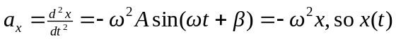 is a solution to Eq. (13.4) if 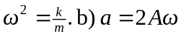 a constant, so Eq. (13.4) is not satisfied. c) 